**Adarsh Rajaram Hegde, Galway Ireand.**

BEER PALACE EPOS APPLICATION

**TABLE OF CONTENT**

**Page Number**

1. **INTRODUCTION 2**
   1. Clients Profile. 2
2. **SYSTEM SPECIFICATION 3**

2.1 System Requirements .. 3

2.2 System Environments. 3

1. **OVERVIEW OF EPOS APPLICATION 3**

3.1 Outline of EPOS application development system.

1. **DATA FLOW DIAGRAMS 4**

4.1 Basic flow diagram of Beer palace EPOS application. 4

4.2 Flow chart of Add Button. 6

4.3 Flow chart of Confirm Button. 7

4.4 Flow chart of Stock Button. 8

4.5 Flow chart of Daily sales report button. 9

4.6 Flow chart of Search transaction button. 10

1. **USER INTERFACE DESIGN 11**

5.1 Main Form 11

5.2 Billing Form 11

5.3 Search Form 11

5.4 Sale Report Form 11

1. **IPLEMENTATION 11**

6.1 Main Form 11

6.2 Billing Form 12

6.3 Management Report Form 15

6.3 Sale Report Form 16

6.4 Search Transaction Form 17

1. **EXCEPTION HANDLING 18**
2. **SCREENSHOTS 19**
3. **TESTING 22**
4. **APPENDIX 32**
5. **INTRODUCTION**

**1.1 Client Profile : -**

Our client Beer Palace, one of the Ireland’s popular leading beverage Off-license Stores in Dublin and Currently expanding its business in Galway, Ireland. Beer Palace is oldest and liquor store which mainly sells famous Irish beers. Beer palace has always been updating its beverage list to suit the present generation and has recently introduced a new shop in Galway (based on various aspects of analysis) consisting only traditional Irish beers, as of now with the view of expanding the collections later. The beer collection mainly based on customer ratings and percentage of customer purchase per month (data collected through customer analytics). The monthly top 15 beers make the top list. Currently 14 different Beers are available for sale and each beer ready to serve customers in 5 different quantities. The details of the different beers along with their price are as follows-

|  |  |  |  |  |  |
| --- | --- | --- | --- | --- | --- |
| Beer Names | Half pint | Small can | Large can | Pint | Keg of beer |
| Guinness Irish Stout | 1.8 | 2.4 | 4 | 5.5 | 12 |
| Beamish Genuine Irish Stout | 1.9 | 2.5 | 4.1 | 5.6 | 12.2 |
| Murphy's Irish Stout | 1.84 | 2.45 | 4.3 | 5.56 | 12.8 |
| McGargles Francis’ Big Bangin’ IPA | 1.83 | 2.45 | 4.5 | 5.5 | 16 |
| Kilkenny Irish Cream Ale | 1.9 | 2.5 | 4.5 | 5.3 | 12.7 |
| Smithwick’s Red Ale | 1.83 | 2.44 | 4.56 | 5.54 | 14.8 |
| Harp Lager | 1.84 | 2.46 | 4.57 | 5.58 | 13.6 |
| O’ Hara’s Irish Stout | 1.93 | 2.64 | 4.66 | 5.64 | 16.8 |
| Porterhouse Temple Lager | 1.9 | 2.43 | 4.76 | 5.74 | 15.8 |
| Rascals Happy Days Session Pale Ale | 1.83 | 2.54 | 4.76 | 5.94 | 13.8 |
| Wicklow Wolf Elevation Pale Ale | 1.93 | 2.48 | 4.58 | 5.94 | 18.8 |
| Galway Bay Althea APA | 1.93 | 2.94 | 4.96 | 5.94 | 19.8 |
| Irish Red ale | 1.893 | 2.84 | 4.86 | 5.84 | 19.68 |
| [White Hag Black Boar](https://www.ratebeer.com/beer/white-hag-black-boar/285037/) | 1.53 | 2.44 | 4.86 | 6.54 | 18.8 |

Table 1 different types of beer and it is price in Euros.

**2. SYSTEM SPCEIFICATION**

**2.1 System Requirements: -**

Development of the Electronic Point of Sale (EPOS) Application for the Beer palace Galway store’s daily sales management. The EPOS Application should process the daily sales and record the sale of different beers available in day-to-day stock availability. It also provides inventory management report as and when requested by staff to keep the track of the stock levels. One of the main functionalities of EPOS should include is Management able to search the transactions with the either Transaction ID or Date of transaction. The staff thorough EPOS application should be able to daily sales report, which contains the details of the sales completed that day till that time.

**2.2 System Environments: -**

The development domain - Visual studio Express 2017 (Windows).

The dataflow diagrams - [www.lucidchart.com](http://www.lucidchart.com)

The programming Language- C# (Windows application).

**3.OVERVIEW OF EPOS APPLICATION**

**3.1 Outline of EPOS application development system: -**

The Beer palace EPOS application was developed in C# visual studio environment. Visual studio is application development software which can produce native code and managed code. The application was built with following functionalities.

* Daily sales of beers.
* Transaction details generation and storing it in file for backup use.
* Updating and manipulating stock availability on day-to-day basis.
* Creating and storing the daily sales report in text file.

The Beer Palace EPOS application on opening, availability of stocks of different beer available is loaded to a 2-Dimensional array from Stock text file updated by the end of the day. Using the EPOS application, the sale assistant able to bill the selected beer and its container size with quantity choice by respected customer through list-box provided. The quantity of the specific beer with specific container size also be increased and reduced, which in turn reflects in the total price in the corresponding text box. The changes in quantity should be reflected dynamically in the total cost text box.

After the selection of beer with their container size and quantity, if any extra items are added by mistake it can be simply removed using Minus tab (Which reduces the quantity value by one at a time). On Add tab press the selected items are added cart and displayed in grid-view. The selected items are displayed along with a distinct six-digit transaction ID as shown. The sales assistant can add any number of beers to the cart based on the choice of customer. The quantity of the beer available is compared with stock availability, respectively.

Once the items are added to the cart, the sales assistant would then check out the cart using ‘Confirm tab’ button which pop up a message asking sales assistant to proceed with the following transaction details. Once sales assistant proceeds with opting Yes in pop up message, the transaction details are stored in text file (refer Figure).

The management report and search transactions button open a new form (rendering the Main form inactive). The management report buttons on click displays availability of stocks of beers. The sales assistant can also trace the specific transaction details using transaction ID and transaction date. This functionality implemented to support customer queries and transaction details verification process in the background. If a customer remembers just date of the transaction, through transaction search by date button sales assistant able to retrieve all transactions completed on that date.

On Sales report click creates a text file and stores all transaction details of the beers sold till that time of the day. The management treat it as crucial information for customer and product analysis. The most sold items in that day can be found in the sales report file. Clear button would clean all selected fields and make it to zero.

1. **DATA FLOW DIAGRAMS**
   1. **Basic flow diagram of Beer palace EPOS application:**

* On loading main form sales assistant able to start the billing or can close the application using Exit tab.
* The start billing tab provides the following options. The beer name and beer size are selected with specific quantity choice of the customers, on Add tab click the selected items are displayed on data grid view cart.
* The gateway comes into picture here, Sales assistant have choice to confirm the order, cancel the selected items or clear the selected items from the list boxes.
* On confirming order, transaction details are written into the text files and on cancelling the order, the stock is updated, and selection focus redirected back to selection lit boxes option.
* Clearing the cart just removes and assign the values to zero and the focus is shifted towards Exit of the application.
* The start billing tab in Main form also provides another direct gateway towards report generation. Management report tab opens sales report form and displays the availability of the stocks. Sales report tab generates daily sales text file in debug folder. The search transaction tab creates Sale Search form and provides search transaction options.

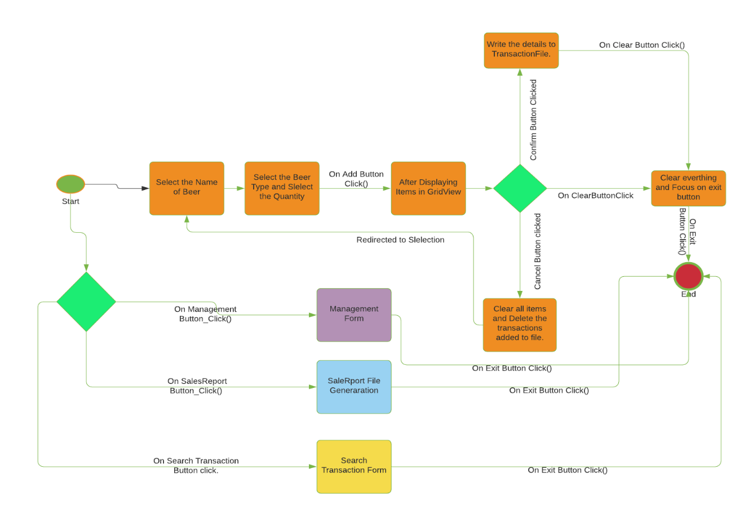

Figure 4.1 Basic workflow diagram

**4.2 Flow chart of Add Button: -**

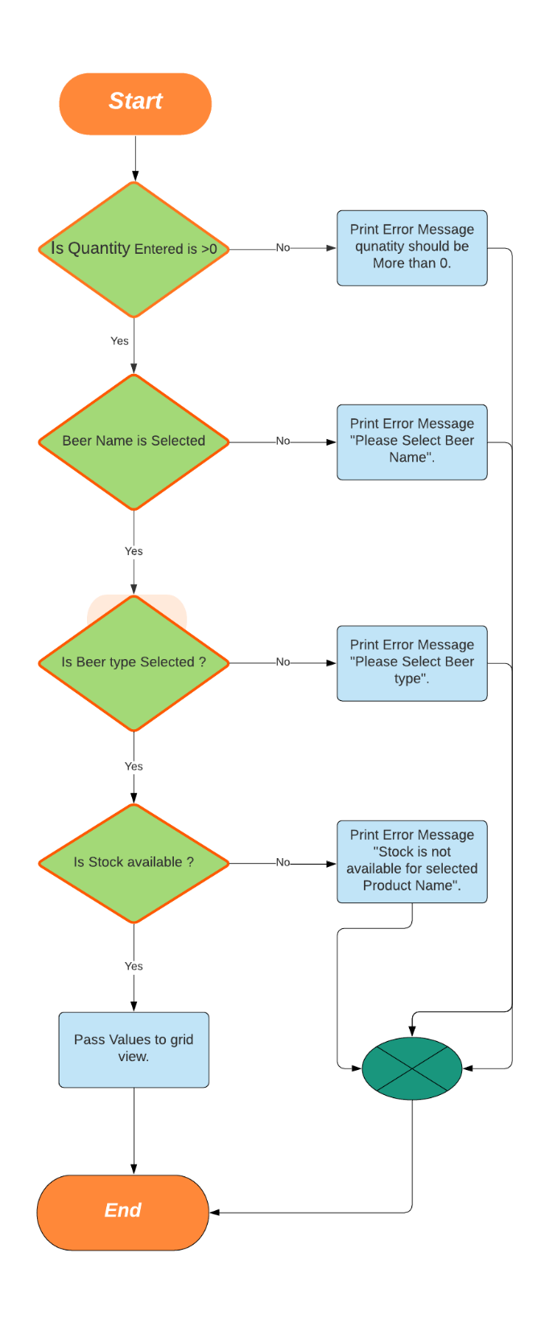

Figure 4.2 Add button flow chart.

* Start: After selection of name and type of the specific beer with the quantity of choice by customer, Sales assistant clicks add button.
* The quantity entered by staff is taken into consideration first, the entered quantity should be more than zero. If it is less than zero a message box displayed saying “quantity should not be zero".
* If the quantity is more than zero, the application checks whether specific beer name is selected from list box or not. If not, then an error message of “Please select the specific beer name” prompted on the screen.
* If beer name is selected from list box, then EPOS verifies whether beer size or type is selected from second list box or not. If not, an error message box popped on scree stating that “please select the specific beer type or size”.
* If beer type or size selected is selected from list box, then EPOS compares selected item with stock availability. If it is out of stock, a message box is appearing on screen with “stock is not available for selected Items” message.
* If stock is available, then the selected items is moved to grid view and focus shifted to Confirm order button.
* Here End is intermediate event which specifies the completion of the ADD button click procedure.

**4.3 Flow chart of Confirm Button: -**

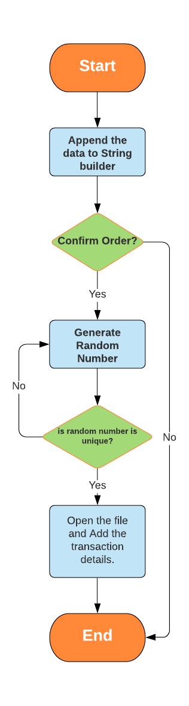

Figure 4.3 Flow chart of Confirm Button.

* Start: After selection of items by choice of customer and moving to cart, Sales assistant clicks confirm button.
* A message is prompted on the screen with the transaction details and ask to whether to confirm the order and Yes or No options are provided.
* If yes, then EPOS application generates a random transaction ID for each transaction. The transaction ID must be unique to append to file.
* If generated transaction ID is not unique than application generates another until it will find it as unique.
* If it is unique, then transaction details containing Transaction ID, Transaction date, Product name, Product type and Total cost is appended to “TransactionFile” text file.
* For an instance if customer does not want to confirm the order, then No option is selected where application is terminated without appending transaction details to the File.
* The transaction ID is made unique to reduce the ambiguity among it. Transaction date is added to analyse the sales and trace the daily sales of items.
* End: here end event is intermediate event and focus shifted to Clear button.

**4.4 Flow chart of Stock Button: -**

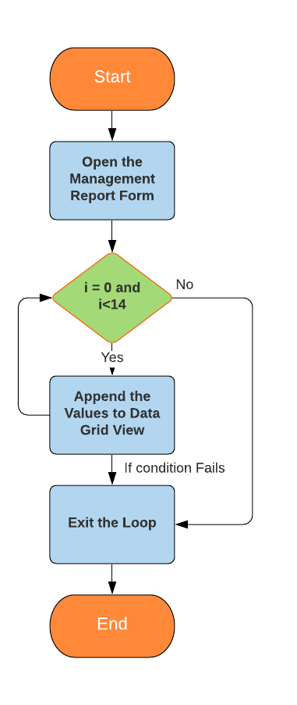

* When Sale staff clicks Management report button in the billing form, The Sale report form is displayed.
* The daily opening stock and closing stock is fetched from the file. The opening stock is stored in the stock 2-dimensional array and a copy is maintained as temporary stock.
* On temporary array all successful transaction stock is updated, respectively.
* The updated temporary array elements are appended to grid view and all the available stock is displayed in table manner.

Figure 4.4 Flow chart of Stock Button.

**4.5 Flow chart of Daily sales report button.**

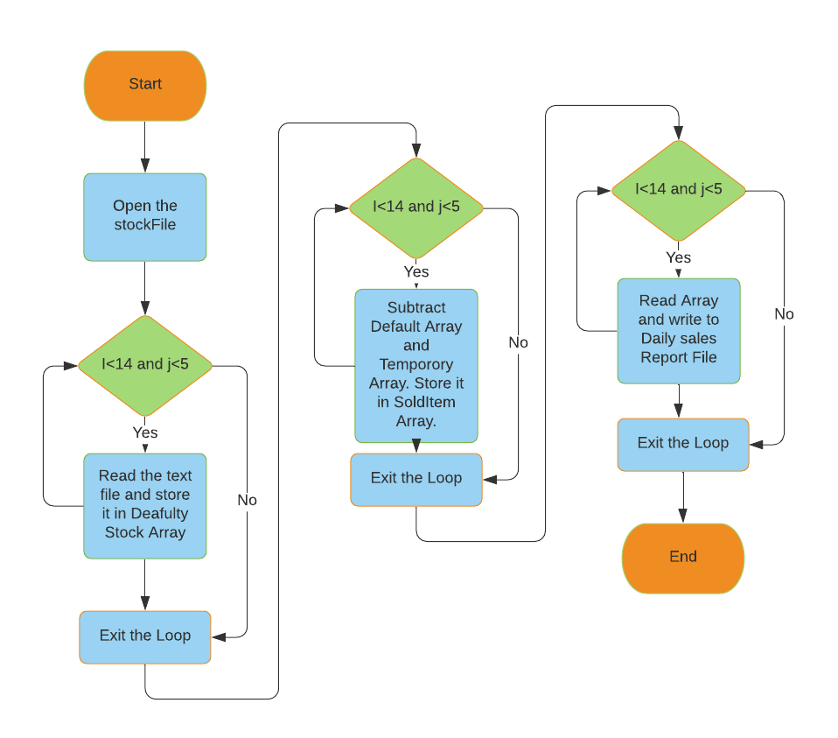

Figure 4.5 Flow chart of Daily sales report button.

* This is important functionality of the Beer Palace EPOS application; the sale staff can generate the daily sales report whenever they want.
* On sale report button click, the stock file in debug folder is opened and it contains the opening stock of the day.
* The contents of the file are read and stored in 2- dimensional array “default stock” using branching statement.
* Once the contents are stored next comes Array elements subtraction, the daily transaction details are updated with temporary 2-deminsional array.
* The difference between two arrays is stored in Sold item 2-dimensional array using the branching statements.
* The Sold item array contains the total items sold in day till that time. The elements are read and write to the text file with additional details such as date, total cost, and total sales.

**4.6 Flow chart of Search transaction button: -**

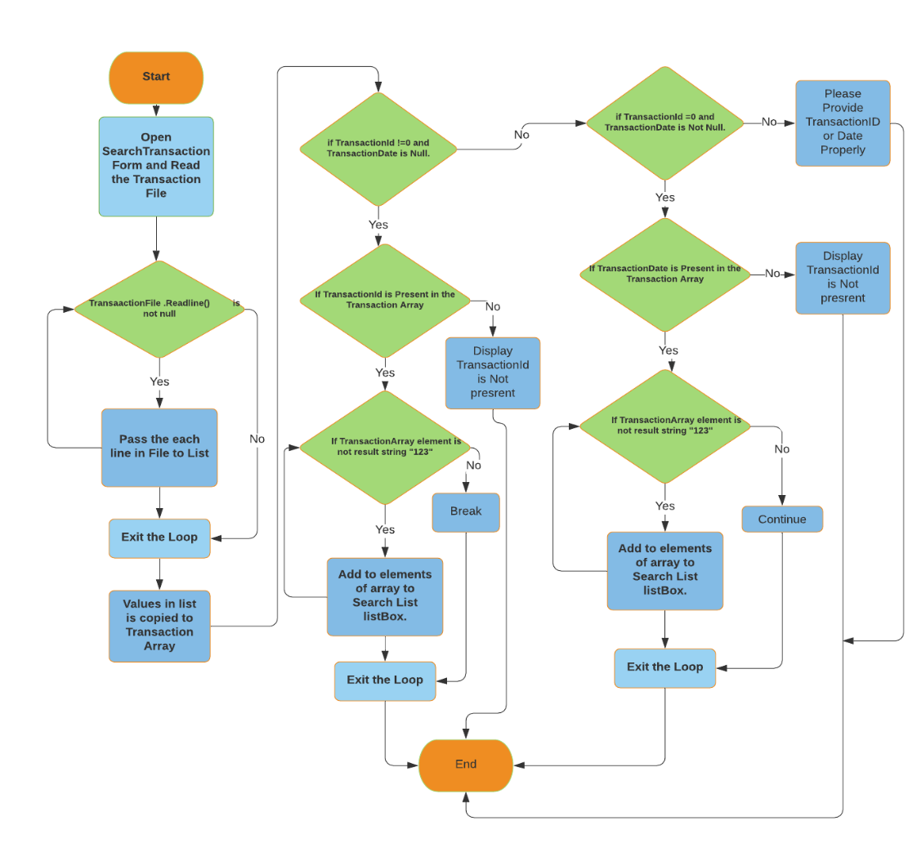

Figure 4.6 Flow chart of Search transaction button.

* On search button click, the search transaction form is loaded and two options for searching transactions is provided for sale staff. The transactions can be searched by entering transaction ID or transaction date.
* If transaction ID or Transaction date is entered, the text file containing the transaction details is opened and the contents is copied to collection (list).
* The decision construct verifies whether the entered Transaction ID or Date is present in the collection or not.
* If it is present using the branch statement elements present from the index of Transaction ID or date entered is displayed in list box.
* If the entered Transaction ID or date is not present, then an error message stating, “The entered transaction ID or transaction Date is not situated with any transactions”.
* Here, while developing application used string “123” as reference or end point of each transactions.

**5. UI DESIGN**

1. **Main Form: -**

The main form is simple, designed with the two buttons and they are Start billing and Exit buttons. The Main form is displayed when the Beer palace EPOS application is loaded (refer Screenshot 1.1 in Screenshot section).

* 1. **Billing Form: -**

The billing form consists of major functionalities of the EPOS application, it consists of eight buttons in which three buttons are related to report generation and rest is associated with daily sales. The interface is created using list boxes, Buttons and Data grid view.

* 1. **Search Form: -**

The search form provides the user to choose to search by transaction ID or Date by providing two text boxes and displays the results on the window by clicking on Search button. Two additional buttons are provided to Clear the form and Exit the form.

* 1. **Sale Report Form: -**

The stock report form displays the stock remaining in the inventory or exit the window.

1. **IMPLEMENTATION** 
   1. **Main Form: -**

The main form is simple, designed with the two buttons and they are Start billing and Exit buttons. The Main form is displayed when the Beer palace EPOS application is loaded (refer Screenshot 1.1 in Screenshot section).

* **Start Billing Button: -**

On clicking the start billing button, Billing form is loaded over the main form. Billing form has many functionalities which can be accessed by the sale staff.

|  |
| --- |
| * Code which instanticiates BillingForm (Object creation).   BillingForm BillingObject = new BillingForm();   * Code to dispaly the content of the Billing Form on StartBilling button click.   BillingObject.ShowDialog(); |

Logic block 6.11 Code which loads Start billing form.

* **Exit Button: -**

On clicking the exit button, the Beer EPOS application is closed.

* 1. **Billing Form : -**

The billing form consists of major functionalities of the EPOS application, it consists of eight buttons in which three buttons are related to report generation and rest is associated with daily sales. The interface is created using list boxes, Buttons and Data grid view.

The global variables are assigned and initialized to specified values. The Beer name array, Beer Size array and Price array is assigned to specified values.

|  |  |  |
| --- | --- | --- |
| Variable Name | Variable Type | Description |
| BeerNameArray | string[] | Beer available for sale (15). |
| PriceArray | double[,] | Price for each beer-by-beer size (75).. |
| BeerSizeArray | string[] | Sizes common to most items (5) |
| StockArray | int[,] | Total stock of beer type (14x5 matrix). |
| DefaultArray | int[,] | Default stock (14x5 matrix). |
| TemporaryArray | int[,] | Temporary stock on which operations happens. |
| CURRENCY | string | Currency symbol “Euro”. |
| FinalValue | double | Final cost of the transactions. |
| InitialCost | double | Initial cost of the transactions. |

Table No.6.2 Global variable declaration.

* **Add Button: -**

On clicking add button, the selected items are added to cart and ready for checkout. Exceptions are handled with standard procedure.

* After selection of name and type of the specific beer with the quantity of choice by customer, Sales assistant clicks add button.
* The quantity entered by staff is taken into consideration first, the entered quantity should be more than zero. If it is less than zero a message box displayed saying “quantity should not be zero".
* If the quantity is more than zero, the application checks whether specific beer name is selected from list box or not. If not, then an error message of “Please select the specific beer name” prompted on the screen.
* If beer name is selected from list box, then EPOS verifies whether beer size or type is selected from second list box or not. If not, an error message box popped on scree stating that “please select the specific beer type or size”.
* If beer type or size selected is selected from list box, then EPOS compares selected item with stock availability. If it is out of stock, a message box is appearing on screen with “stock is not available for selected Items” message.
* If stock is available, then the selected items is moved to grid view and focus shifted to Confirm order button.
* Important logic blocks implemented on Add button click.

|  |
| --- |
| * If stock is available then reduce the quantity from stock available.   TempStockArray[BeerNameIndexSelected, BeerSizeIndexSelected] = TempStockArray[BeerNameIndexSelected, BeerSizeIndexSelected] - QuantityEntered;   * Code which calculates Basic cost.   InitialTotalCost = PriceArray[BeerNameIndexSelected,  BeerSizeIndexSelected] * QuantityEntered;  ProductName = BeerNameArray[BeerNameIndexSelected];  ProductType = BeerSizeArray[BeerSizeIndexSelected];   * Calling Display method through call by value procedure.   DisplayDataGrid(ProductName, ProductType, QuantityEntered, InitialTotalCost);  FinalValue = FinalValue + InitialTotalCost;  TotalCostValueTextBox.Text = CURRENCY + FinalValue.ToString(); |

Logic block 6.21 Add button implementation logic.

**Confirm Button: -**

On clicking confirm button, if yes is selected from message prompt the items selected and displayed in cart with details are loaded to text file (TransactionFile.txt in debug folder).

* A message is prompted on the screen with the transaction details and ask to whether to confirm the order and Yes or No options are provided.
* If yes, then EPOS application generates a random transaction ID for each transaction. The transaction ID must be unique to append to file.
* If generated transaction ID is not unique than application generates another until it will find it as unique.
* If it is unique, then transaction details containing Transaction ID, Transaction date, Product name, Product type and Total cost is appended to “TransactionFile” text file.
* For an instance if customer does not want to confirm the order, then No option is selected where application is terminated without appending transaction details to the File.
* The transaction ID is made unique to reduce the ambiguity among it. Transaction date is added to analyse the sales and trace the daily sales of items.
* Important logic blocks implemented on Confirm button click.

|  |
| --- |
| * calling random number generation method.   RandomNumberGenerator(ref RandomNumber);  StreamReader InputFile;  InputFile = File.OpenText("TransactionsFile.txt");  while (!InputFile.EndOfStream){  Temp = InputFile.ReadLine();   * To check and generate unique random number.   if (Temp == RandomNumber.ToString()){  RandomNumberGenerator(ref RandomNumber);}}  InputFile.Close();   * Code which appends transaction details from gridview to text file.   StreamWriter FileOpen;  FileOpen = File.AppendText("TransactionsFile.txt");  FileOpen.WriteLine(RandomNumber);  FileOpen.WriteLine(GetDateTime.ToShortDateString());  for (int i = 0; i < DataGridCart.Rows.Count; i++){  for (int j = 0; j < 4; j++){  FileOpen.WriteLine(DataGridCart[j, i].Value?.ToString());}}  FileOpen.WriteLine("123");  FileOpen.Close(); |

Logic block 6.22 Confirm button implementation logic.

* **Cancel Button: -**
* On cancel button, the stock manipulated during adding to the cart is updated with original value and selected items are cleared.
* Important logic blocks implemented on Cancel button click.

|  |
| --- |
| * code to reduce the stock added while confirming.   TempStockArray[BeerNameIndexSelected, BeerSizeIndexSelected] = TempStockArray[BeerNameIndexSelected, BeerSizeIndexSelected] + QuantityEntered;  InitialTotalCost = 0;  DataGridCart.Rows.Clear();  QuantityValuesTextBox.Clear();} |

Logic block 6.23 Cancel button implementation logic.

* **Clear Button: -**

On clicking clear button, the selected values in the form are cleared and assigned to 0. focus shifted to Exit button.

* **Exit Button: -**

On clicking exit button, the application closes billing form and saves the closing stock to the stock file.

* 1. **Management Report button: -**

On clicking management report button, the application opens Sale report form and displays available stock in data grid view.

* When Sale staff clicks Management report button in the billing form, The Sale report form is displayed.
* The daily opening stock and closing stock is fetched from the file. The opening stock is stored in the stock 2-dimensional array and a copy is maintained as temporary stock.
* On temporary array all successful transaction stock is updated, respectively.
* The updated temporary array elements are appended to grid view and all the available stock is displayed in table manner.
* Important logic blocks implemented on Management Report button click.

|  |
| --- |
| * Code to create Management Report Form.   SalesReportForm ManagementReport = new SalesReportForm();   * Code which displays Mangement Report Form.   ManagementReport.ShowDialog();   * Billing form isntance is created.   BillingForm Obj = new BillingForm();   * Branching statement for appending values to data grid view.   for (int i = 0; i < 14; i++){  ManagementReportDataGrid.Rows.Add(Obj.BeerNameArray[i],  BillingForm.TempStockArray[i, 0],  BillingForm.TempStockArray[i, 1],  BillingForm.TempStockArray[i, 2],  BillingForm.TempStockArray[i, 3],  BillingForm.TempStockArray[i, 4]);} |

Logic block 6.24 Management report button implementation logic.

* 1. **Sale Report Button: -**

On clicking sale report button, the application generates daily sale report file in debug folder with all the transaction details.

* This is important functionality of the Beer Palace EPOS application; the sale staff can generate the daily sales report whenever they want.
* On sale report button click, the stock file in debug folder is opened and it contains the opening stock of the day.
* The contents of the file are read and stored in 2- dimensional array “default stock” using branching statement.
* Once the contents are stored next comes Array elements subtraction, the daily transaction details are updated with temporary 2-deminsional array.
* The difference between two arrays is stored in Sold item 2-dimensional array using the branching statements.
* The Sold item array contains the total items sold in day till that time. The elements are read and write to the text file with additional details such as date, total cost, and total sales.
* Important logic blocks implemented on sales Report button click.

|  |
| --- |
| * code which uses Loop to read from file and stores in array.   for (int i = 0; i < 14; i++){  for (int j = 0; j < 5; j++){  DefaultStock[i, j] = int.Parse(InputFile.ReadLine());}}  InputFile.Close();   * code to find out the daily sales of item and stored in SoldItem array.   for (int i=0;i<14;i++){  for(int j = 0; j < 5; j++)  SoldItemArray[i, j] = DefaultStock[i, j] - TempStockArray[i, j];}} |

Logic block 6.25 Sales report button implementation logic.

* 1. **Search Transaction Button: -**

On clicking search transaction buttons, the application opens Search form and provides options to search the transaction details.

* On search button click, the search transaction form is loaded and two options for searching transactions is provided for sale staff. The transactions can be searched by entering transaction ID or transaction date.
* If transaction ID or Transaction date is entered, the text file containing the transaction details is opened and the contents is copied to collection (list).
* The decision construct verifies whether the entered Transaction ID or Date is present in the collection or not.
* If it is present using the branch statement elements present from the index of Transaction ID or date entered is displayed in list box.
* If the entered Transaction ID or date is not present, then an error message stating, “The entered transaction ID or transaction Date is not situated with any transactions”.
* Here, while developing application used string “123” as reference or end point of each transactions.
* Important logic blocks implemented on Search transaction button click and here searching transaction date logic is used also for transaction date search logic just append “continue” instead of “Break”.

|  |
| --- |
| * Code to create Search transactions Form.   SearchForm searchObject = new SearchForm();   * Code which displays search transactions Form.   searchObject.ShowDialog();   * Decision construct check whether array contains Transaction ID.   if (TransactionArraySearch.Any(x => x == ID)){   * code to fetch the index of the Transaction ID presrent in Array.   var index = Array.IndexOf(TransactionArraySearch, ID);  for (int i = index; i < TransactionArraySearch.Length; i++){   * Decision construct to retrive specific lines.   if (TransactionArraySearch[i] != result){   * code to add the details to listbox and Content array.   content[i] = TransactionArraySearch[i];  SearchDetailsListBox.Items.Add(content[i]); }  else{break; } |

Logic block 6.26 Search transaction button implementation logic.

1. **EXCEPTION HANDLING**

**7.1 Exception Handled in EPOS application.**

The following exceptions are handled using try and catch block.

|  |  |
| --- | --- |
| **Name of the Exceptions** | **Handled with message** |
| Quantity less than or equal to Zero | Message displayed: “Please enter the item quantity more than 0”. |
| Non selection of Beer Name list box | Message displayed: “Please select the Beer Name form the list box”. |
| Non selection of Beer Size list box | Message displayed: “Please select the Beer Size form the list box”. |
| Empty text box: Search Form Search Button Click. | Message displayed: “Please enter appropriate Transaction ID or Transaction Date” |
| Invalid Transaction ID: Search Form. | Message displayed: “No transaction is available on this ID; Transaction ID is not found” |
| Invalid Transaction Date: Search Form | Message displayed: “No transaction is available on this date; Transaction date is not found” |

1. **SCREENSHOTS TAKEN AT RUN TIME**
   1. **Form Loading**
   2. **Main Form**

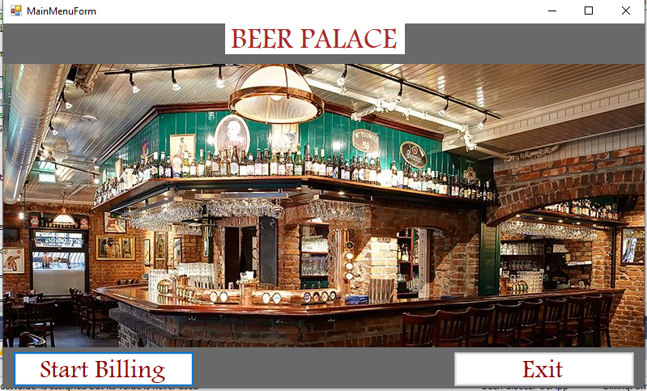

Screenshot No 9.11 on loading Form Main.

* 1. **Billing Form**

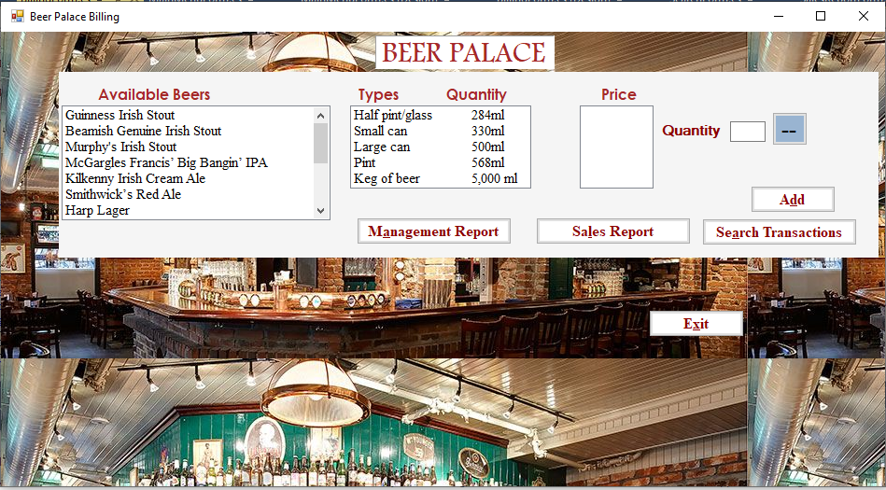Screenshot No 9.12 on loading Billing Form.

* 1. **Search Form**

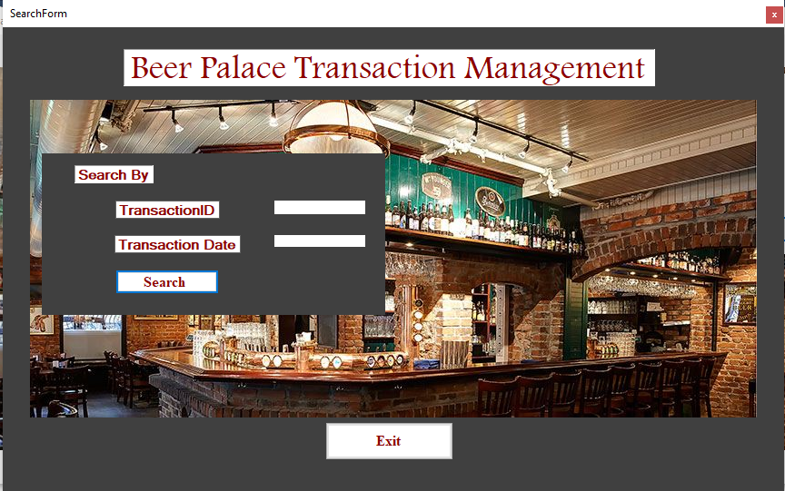

Screenshot No 9.13 on loading Search Form.

* 1. **Management Report Form.**

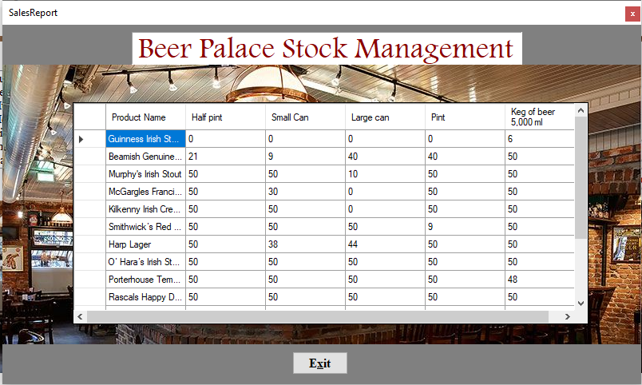

Screenshot No 9.14 on loading Stock Management Form

1. **TESTING**
   1. **Test Cases with runtime screenshots.**

**Testing Add button functionality.**

|  |  |  |  |  |
| --- | --- | --- | --- | --- |
| Test Case Input Values | Testing Functionality  Add Button | Expected Result | Test Result | Remarks |
| Name: Irish stout.  Size: Half pint/glass.  Quantity: 5 | Addition of selected items to the cart. | Added to the cart.  Total cost will be € 9. | Items are added to cart.  Total cost is €9. | Test case is passed. |
| Name: No Selection  Size: Half pint/glass  Quantity: 5 | Addition of selected items to cart without Product Name selection. | Exception handled and error message is displayed on screen. | Exception message is displayed stating that “ Please enter Beer Name”. | Test case is passed. |
| Name: Irish stout.  Size: No selection.  Quantity: 5 | Addition of selected items to cart without Product Type selection. | Exception handled and error message is displayed on screen. | Exception message is displayed stating that “ Please enter Beer Size”. | Test case is passed. |
| Name: Irish stout.  Size: Half pint/glass.  Quantity: 0 | Addition of selected items to cart without Product Type selection. | Exception handled and error message is displayed on screen | Exception message is displayed stating that “ quantity should be more than 0”. | Test case is passed. |

Table 10.1 Test results of Add button functionality.

**Screenshots of test cases above:**

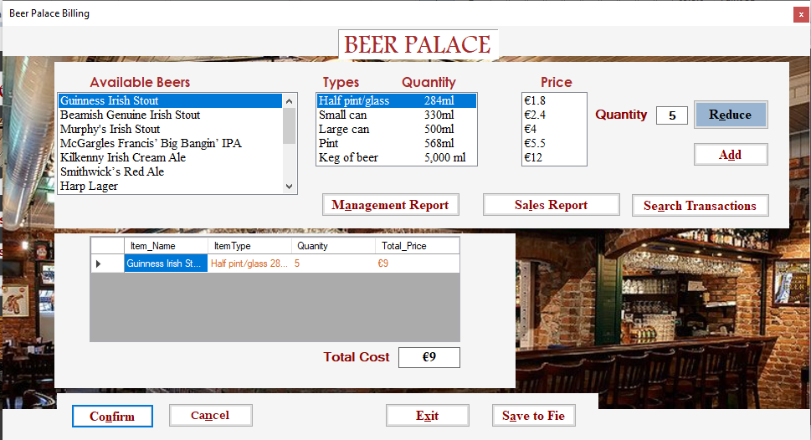

Figure 10.11 Test case 1 of Add functionality test.

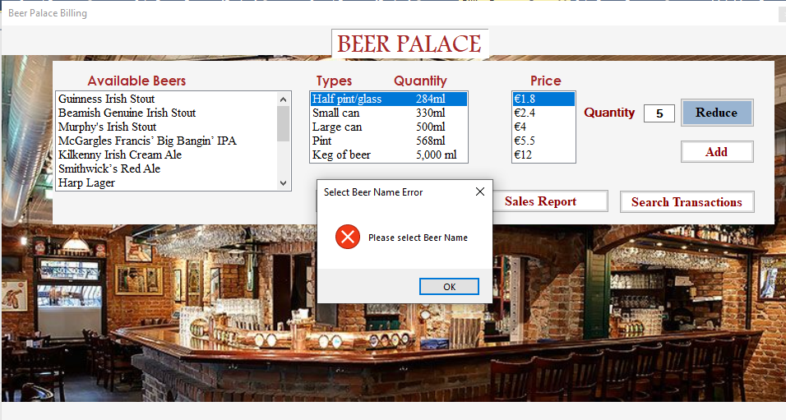

Figure 10.12 Test case 2 of Add functionality test.

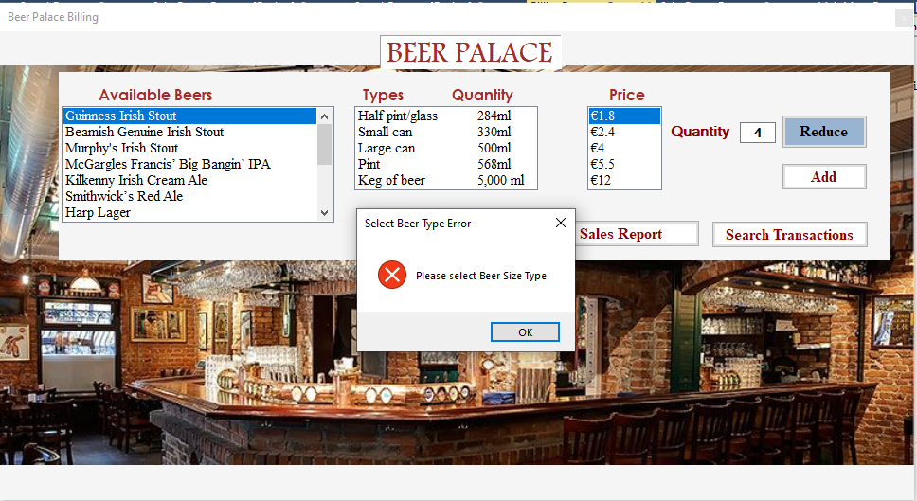

Figure 10.13 Test case 3 of Add functionality test.

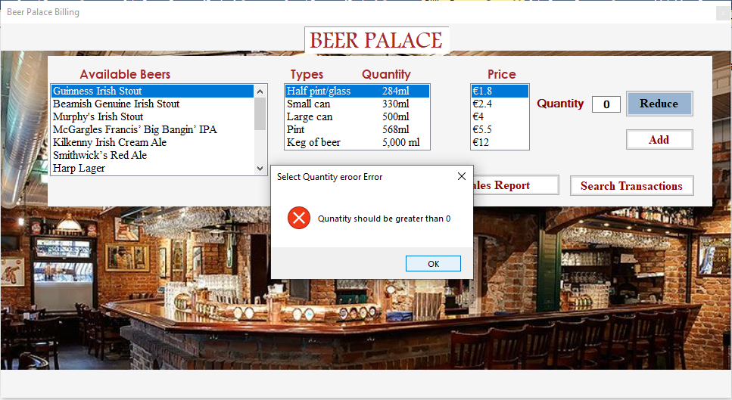

Figure 10.14 Test case 4 of Add functionality test.

**10.2 Testing Confirm Button Functionality.**

|  |  |  |  |  |
| --- | --- | --- | --- | --- |
| Test Case Input Values | Testing Functionality  ConfirmButton | Expected Result | Test Result | Remarks |
| Name: Irish stout.  Size: Half pint/glass.  Quantity: 5  Added to the cart | Confirming the order with generation of unique transaction ID and message prompt. | Asking staff to confirm with message prompt and transactions details are generated | A message is prompted with selected items and transaction details with Yes or No option. | Test case is passed. |
| Name: Irish stout.  Size: Half pint/glass.  Quantity: 5  Added to the cart | After selecting Yes addition of transaction details to TransactionFile.txt in debug folder. | The transaction details are successfully written into File. | The unique transaction Id is generated, and details are written to file. | Test case is passed. |

Table 10.2 Test results of Confirm button functionality.

**Screenshots of test cases above:**

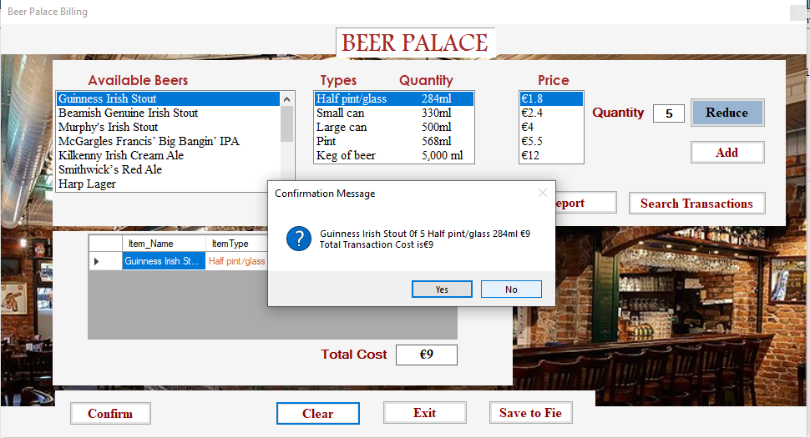

Figure 10.21Test case 1 of confirm functionality test.

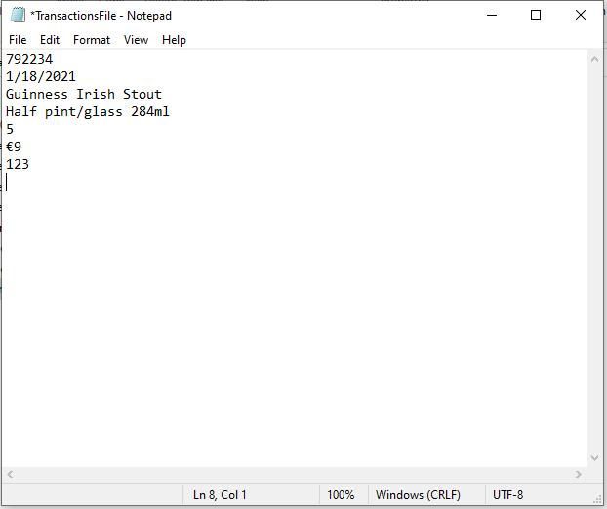

Figure 10.22 Test case 2 of confirm functionality test.

**10.3 Testing Reduce Button Functionality.**

|  |  |  |  |  |
| --- | --- | --- | --- | --- |
| Test Case Input Values | Testing Functionality  Reduce Button | Expected Result | Test Result | Remarks |
| Name: Irish stout.  Size: Half pint/glass.  Quantity: 5  Quantity Reduced: 1 | Entered quantity is reduced with one value at time | Quantity Original: 5  Quantity reduced: 4 | Quantity Original: 5  Quantity reduced: 4 | Test case is passed. |
| Name: Irish stout.  Size: Half pint/glass.  Quantity: 1  Quantity Reduced: 1 | Entered quantity is reduced with one value at time | Exception handled and error message is displayed on screen. | Exception message is displayed stating that “ The quantity cannot be 0”. | Test case is passed. |

Table 9.3 Test results of Reduce button functionality.

**Screenshots of test cases:**

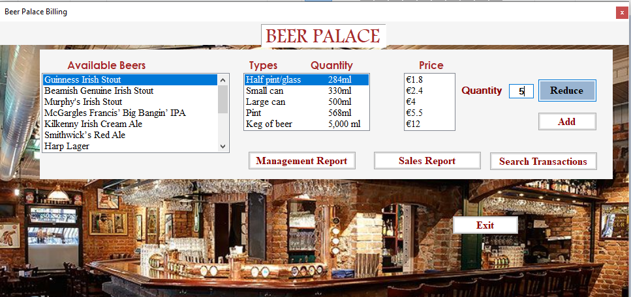

Figure 10.31 Test case 1 of Reduce functionality test.

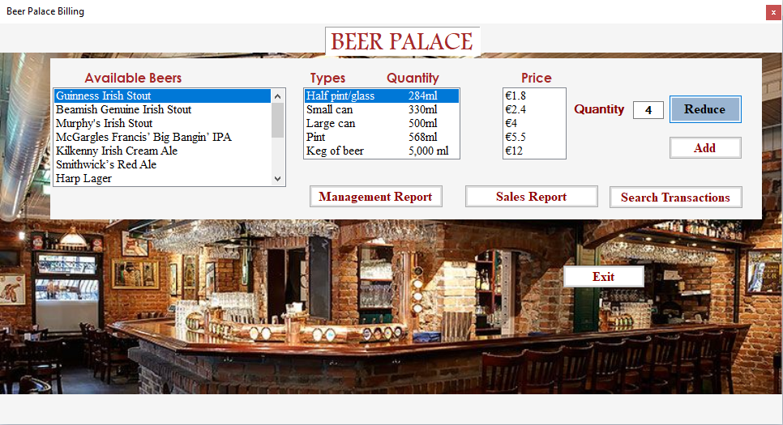

Figure 10.32 Test case 1 of Reduce functionality test.

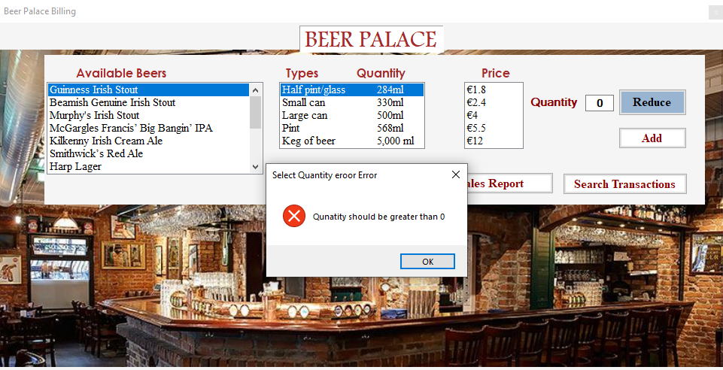

Figure 10.33 Test case 2 of Reduce functionality test.

**10.4 Testing Search Button Functionality.**

|  |  |  |  |  |
| --- | --- | --- | --- | --- |
| Test Case Input Values | Testing Functionality of  Search Button | Expected Result | Test Result | Remarks |
| Transaction ID:  Transaction date: Null | Searching transaction ID in the collection. | Transaction Id is Present and transaction details are displayed in listbox. | Transaction Id is Present and transaction details are displayed in listbox. | Test case is passed. |
| Transaction ID: Null  Transaction date: 1/18/2021 | Searching transaction Date in the collection. | Transaction Date is Present and transaction details are displayed in listbox. | Transaction Id is Present and transaction details are displayed in listbox. | Test case is passed. |
| Transaction ID: Null  Transaction date: Null | Searching transaction ID in the collection. | Exception handled and error message is displayed on screen | Exception message is displayed stating that “Please input appropriate Transaction ID or Date”.. | Test case is passed. |
| Transaction ID: 123456  Transaction date: Null | Searching transaction ID in the collection. | Exception handled and error message is displayed on screen | Exception message is displayed stating that “Please input appropriate Transaction ID”.. | Test case is passed. |
| Transaction ID: Null  Transaction date: 17/5/1995 | Searching transaction ID in the collection. | Exception handled and error message is displayed on screen | Exception message is displayed stating that “Please input appropriate Transaction Date”.. | Test case is passed. |

**Screenshots of test cases:**

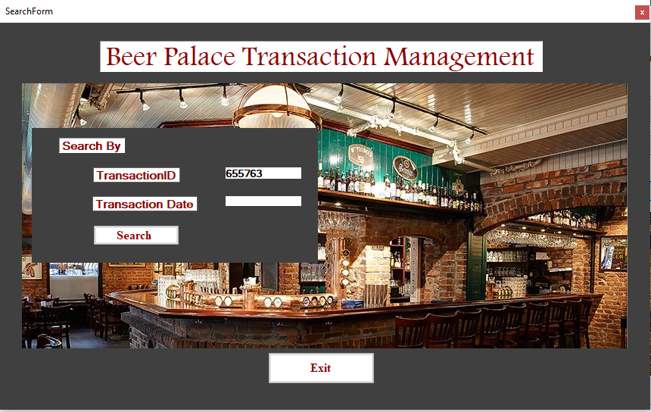

Figure 10.41 Test case 1 of Search functionality test.

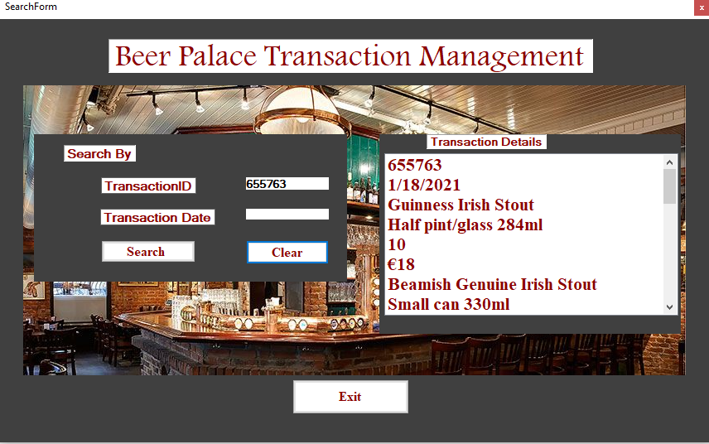

Figure10.42 Test case 1 of Search functionality test.

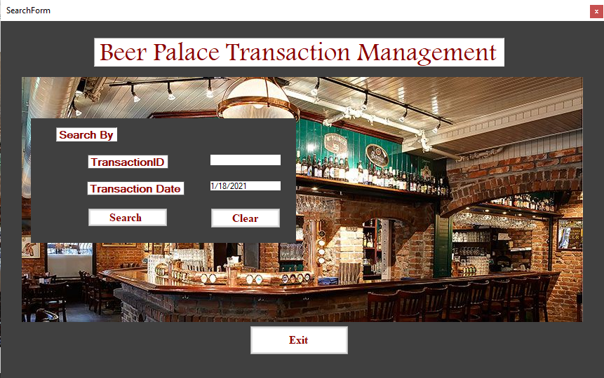

Figure 10.43 Test case 2 of Search functionality test.



Figure 10.44 Test case 2 of Search functionality test.

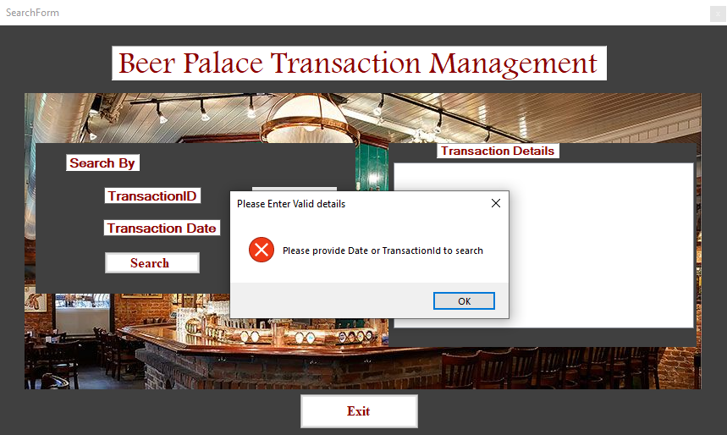

Figure 10.45 Test case 3 of Search functionality test.

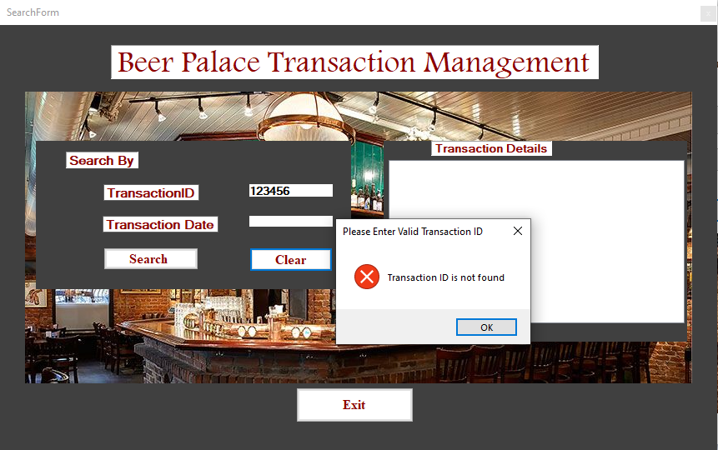

Figure 10.46 Test case 4 of Search functionality test.

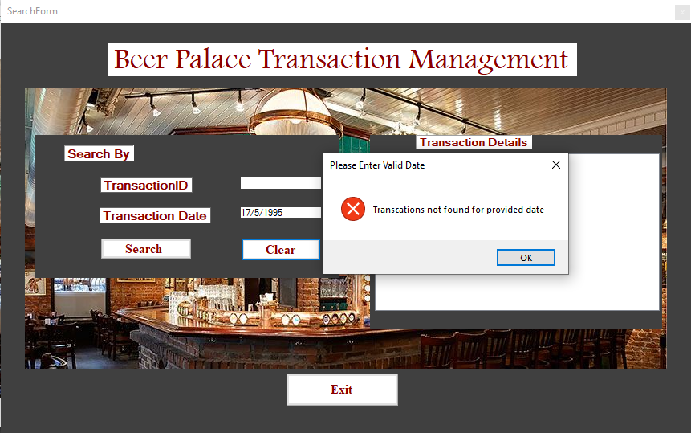

Figure 10.47 Test case 5 of Search functionality test.

**APPENDIX**

**MAIN FORM SOURCE CODE**

**using** System**;**

**using** System**.**Collections**.**Generic**;**

**using** System**.**ComponentModel**;**

**using** System**.**Data**;**

**using** System**.**Drawing**;**

**using** System**.**Linq**;**

**using** System**.**Text**;**

**using** System**.**Threading**.**Tasks**;**

**using** System**.**Windows**.**Forms**;**

**namespace** BeerPalaceEPOSApp

**{**

**public** **partial** class MainMenuForm **:** Form

**{**

**public** MainMenuForm**()**

**{**

InitializeComponent**();**

**}**

**private** void StartBillingButton_Click**(object** sender**,** EventArgs e**)**

**{**

//Code which instanticiates BillingForm (Object creation).

BillingForm BillingObject **=** **new** BillingForm**();**

// Code to dispaly the content of the Billing Form on StartBilling button click.

BillingObject**.**ShowDialog**();**

**}**

**private** void billingToolStripMenuItem_Click**(object** sender**,** EventArgs e**)**

**{**

**}**

**private** void ExitButton_Click**(object** sender**,** EventArgs e**)**

**{**

//Code to close the application.

**this.**Close**();**

**}**

**private** void MainMenuForm_Load**(object** sender**,** EventArgs e**)**

**{**

//Code which changes the visibiltiy of MainForm.

HeadLabel**.**Visible **=** **true;**

StartBillingButton**.**Visible **=** **true;**

ExitButton**.**Visible **=** **true;**

**}**

**}**

**}**

**BILLING FORM SOURCE CODE**

**using** System**;**

**using** System**.**Collections**.**Generic**;**

**using** System**.**ComponentModel**;**

**using** System**.**Data**;**

**using** System**.**Drawing**;**

**using** System**.**IO**;**

**using** System**.**Linq**;**

**using** System**.**Text**;**

**using** System**.**Threading**.**Tasks**;**

**using** System**.**Windows**.**Forms**;**

**namespace** BeerPalaceEPOSApp

**{**

**public** **partial** class BillingForm **:** Form

**{**

**public** BillingForm**()**

**{**

InitializeComponent**();**

**}**

//global variable declaration and assigned to specific values.

DateTime GetDateTime **=** DateTime**.**Now**.**Date**;**

double**[,]** PriceArray **=** **new** double**[**14**,** 5**]** **{** **{** 1.8**,** 2.4**,** 4**,** 5.5**,** 12 **},** **{** 1.9**,** 2.5**,** 4.1**,** 5.6**,** 12.2 **},** **{** 1.84**,** 2.45**,** 4.3**,** 5.56**,** 12.8 **},** **{** 1.83**,** 2.45**,** 4.5**,** 5.5**,** 16 **},** **{** 1.9**,** 2.5**,** 4.5**,** 5.3**,** 12.7 **},** **{** 1.83**,** 2.44**,** 4.56**,** 5.54**,** 14.8 **},** **{** 1.84**,** 2.46**,** 4.57**,** 5.58**,** 13.6 **},** **{** 1.93**,** 2.64**,** 4.66**,** 5.64**,** 16.8 **},** **{** 1.9**,** 2.43**,** 4.76**,** 5.74**,** 15.8 **},** **{** 1.83**,** 2.54**,** 4.76**,** 5.94**,** 13.8 **},** **{** 1.93**,** 2.48**,** 4.58**,** 5.94**,** 18.8 **},** **{** 1.93**,** 2.94**,** 4.96**,** 5.94**,** 19.8 **},** **{** 1.893**,** 2.84**,** 4.86**,** 5.84**,** 19.68 **},** **{** 1.53**,** 2.44**,** 4.86**,** 6.54**,** 18.8 **}** **};**

**public** string**[]** BeerNameArray **{** **get;private** **set;** **}** **=** **new** string**[]** **{** "Guinness Irish Stout"**,** "Beamish Genuine Irish Stout"**,** "Murphy's Irish Stout"**,** "McGargles Francis’ Big Bangin’ IPA"**,** "Kilkenny Irish Cream Ale"**,** "Smithwick’s Red Ale"**,** "Harp Lager"**,** "O’ Hara’s Irish Stout"**,** "Porterhouse Temple Lager"**,** "Rascals Happy Days Session Pale Ale"**,** "Wicklow Wolf Elevation Pale Ale"**,** "Galway Bay Althea APA"**,** "Irish Red ale "**,** "White Hag Black Boar" **};**

string**[]** BeerSizeArray **=** **new** string**[]** **{** "Half pint/glass 284ml"**,** "Small can 330ml"**,** "Large can 500ml"**,** "Pint 568ml"**,** "Keg of beer 5,000 ml" **};**

int**[,]** StockArray **=** **new** int**[**14**,**5**];**

int**[,]** DefaultStock **=** **new** int**[**14**,** 5**];**

**public** static int**[,]** TempStockArray **{** **get;** **private** **set;** **}** **=** **new** int**[**14**,** 5**];**

//Currency is constant which holds Euro currency sybol.

**public** const string CURRENCY **=** "€"**;**

double FinalValue **=** 0**;**

string ProductName**,**ProductType**;**

**private** void ItemQuantityLabel_Click**(object** sender**,** EventArgs e**)**

**{**

**}**

**private** void PriceListBox_Click**(object** sender**,** EventArgs e**)**

**{**

**}**

**private** void label3_Click**(object** sender**,** EventArgs e**)**

**{**

**}**

**private** void PriceForBeerListBox_SelectedIndexChanged**(object** sender**,** EventArgs e**)**

**{**

**}**

**private** void ItemCartGridView_CellContentClick**(object** sender**,** DataGridViewCellEventArgs e**)**

**{**

**}**

**private** void BeerNamesListBox_SelectedIndexChanged**(object** sender**,** EventArgs e**)**

**{**

//dynamic price display for selected Beer names from list box.

int BeerNameIndex **=** BeerNamesListBox**.**SelectedIndex**;**

**switch** **(**BeerNameIndex**)**

**{**

**case** 0**:**

PriceForBeerListBox**.**Items**.**Clear**();**

**for** **(**int x **=** 0**;** x **<** 1**;** x**++)**

**{**

**for** **(**int y **=** 0**;** y **<=** 4**;** y**++)**

**{**

PriceForBeerListBox**.**Items**.**Add**(**CURRENCY **+** PriceArray**[**x**,** y**]);**

**}**

**}**

**break;**

**case** 1**:**

PriceForBeerListBox**.**Items**.**Clear**();**

**for** **(**int x **=** 1**;** x **<** 2**;** x**++)**

**{**

**for** **(**int y **=** 0**;** y **<=** 4**;** y**++)**

**{**

PriceForBeerListBox**.**Items**.**Add**(**CURRENCY **+** PriceArray**[**x**,** y**]);**

**}**

**}**

**break;**

**case** 2**:**

PriceForBeerListBox**.**Items**.**Clear**();**

**for** **(**int x **=** 2**;** x **<** 3**;** x**++)**

**{**

**for** **(**int y **=** 0**;** y **<=** 4**;** y**++)**

**{**

PriceForBeerListBox**.**Items**.**Add**(**CURRENCY **+** PriceArray**[**x**,** y**]);**

**}**

**}**

**break;**

**case** 3**:**

PriceForBeerListBox**.**Items**.**Clear**();**

**for** **(**int x **=** 3**;** x **<** 4**;** x**++)**

**{**

**for** **(**int y **=** 0**;** y **<=** 4**;** y**++)**

**{**

PriceForBeerListBox**.**Items**.**Add**(**CURRENCY **+** PriceArray**[**x**,** y**]);**

**}**

**}**

**break;**

**case** 4**:**

PriceForBeerListBox**.**Items**.**Clear**();**

**for** **(**int x **=** 4**;** x **<** 5**;** x**++)**

**{**

**for** **(**int y **=** 0**;** y **<=** 4**;** y**++)**

**{**

PriceForBeerListBox**.**Items**.**Add**(**CURRENCY **+** PriceArray**[**x**,** y**]);**

**}**

**}**

**break;**

**case** 5**:**

PriceForBeerListBox**.**Items**.**Clear**();**

**for** **(**int x **=** 5**;** x **<** 6**;** x**++)**

**{**

**for** **(**int y **=** 0**;** y **<=** 4**;** y**++)**

**{**

PriceForBeerListBox**.**Items**.**Add**(**CURRENCY **+** PriceArray**[**x**,** y**]);**

**}**

**}**

**break;**

**case** 6**:**

PriceForBeerListBox**.**Items**.**Clear**();**

**for** **(**int x **=** 6**;** x **<** 7**;** x**++)**

**{**

**for** **(**int y **=** 0**;** y **<=** 4**;** y**++)**

**{**

PriceForBeerListBox**.**Items**.**Add**(**CURRENCY **+** PriceArray**[**x**,** y**]);**

**}**

**}**

**break;**

**case** 7**:**

PriceForBeerListBox**.**Items**.**Clear**();**

**for** **(**int x **=** 7**;** x **<** 8**;** x**++)**

**{**

**for** **(**int y **=** 0**;** y **<=** 4**;** y**++)**

**{**

PriceForBeerListBox**.**Items**.**Add**(**CURRENCY **+** PriceArray**[**x**,** y**]);**

**}**

**}**

**break;**

**case** 8**:**

PriceForBeerListBox**.**Items**.**Clear**();**

**for** **(**int x **=** 8**;** x **<** 9**;** x**++)**

**{**

**for** **(**int y **=** 0**;** y **<=** 4**;** y**++)**

**{**

PriceForBeerListBox**.**Items**.**Add**(**CURRENCY **+** PriceArray**[**x**,** y**]);**

**}**

**}**

**break;**

**case** 9**:**

PriceForBeerListBox**.**Items**.**Clear**();**

**for** **(**int x **=** 9**;** x **<** 10**;** x**++)**

**{**

**for** **(**int y **=** 0**;** y **<=** 4**;** y**++)**

**{**

PriceForBeerListBox**.**Items**.**Add**(**CURRENCY **+** PriceArray**[**x**,** y**]);**

**}**

**}**

**break;**

**case** 10**:**

PriceForBeerListBox**.**Items**.**Clear**();**

**for** **(**int x **=** 10**;** x **<** 11**;** x**++)**

**{**

**for** **(**int y **=** 0**;** y **<=** 4**;** y**++)**

**{**

PriceForBeerListBox**.**Items**.**Add**(**CURRENCY **+** PriceArray**[**x**,** y**]);**

**}**

**}**

**break;**

**case** 11**:**

PriceForBeerListBox**.**Items**.**Clear**();**

**for** **(**int x **=** 11**;** x **<** 12**;** x**++)**

**{**

**for** **(**int y **=** 0**;** y **<=** 4**;** y**++)**

**{**

PriceForBeerListBox**.**Items**.**Add**(**CURRENCY **+** PriceArray**[**x**,** y**]);**

**}**

**}**

**break;**

**case** 12**:**

PriceForBeerListBox**.**Items**.**Clear**();**

**for** **(**int x **=** 12**;** x **<** 13**;** x**++)**

**{**

**for** **(**int y **=** 0**;** y **<=** 4**;** y**++)**

**{**

PriceForBeerListBox**.**Items**.**Add**(**CURRENCY **+** PriceArray**[**x**,** y**]);**

**}**

**}**

**break;**

**case** 13**:**

PriceForBeerListBox**.**Items**.**Clear**();**

**for** **(**int x **=** 13**;** x **<** 14**;** x**++)**

**{**

**for** **(**int y **=** 0**;** y **<=** 4**;** y**++)**

**{**

PriceForBeerListBox**.**Items**.**Add**(**CURRENCY **+** PriceArray**[**x**,** y**]);**

**}**

**}**

**break;**

**}**

**}**

**private** void label2_Click**(object** sender**,** EventArgs e**)**

**{**

**}**

**private** void Form1_Load**(object** sender**,** EventArgs e**)**

**{**

//Code which Changes the visibility of Form.

ProductPanel**.**Visible **=** **true;**

ButtonPanelOne**.**Visible **=** **false;**

ExitButtonTwo**.**Visible **=** **true** **;**

DataGridViewPanel**.**Visible **=** **false;**

//The Opening stock is loaded from the file and stored in stock array.

StreamReader InFile**;**

InFile **=** File**.**OpenText**(**"StockFile.txt"**);**

**for(**int i**=**0**;** i**<**14**;**i**++)**

**{**

**for(**int j**=**0**;** j**<**5**;**j**++)**

**{**

StockArray**[**i**,** j**]** **=** int**.**Parse**(**InFile**.**ReadLine**());**

**}**

**}**

InFile**.**Close**();**

//code in which loaded Stock is copied to Temporary Array for daily operation.

Array**.**Copy**(**StockArray**,** TempStockArray**,** StockArray**.**Length**);**

**}**

**private** void button1_Click**(object** sender**,** EventArgs e**)**

**{**

//Local variable declaration.

int QuantityReducedValue **=** int**.**Parse**(**QuantityValuesTextBox**.**Text**);**

**try**

**{**

// decison construct to check quantity reduced is 0.

**if** **(**QuantityReducedValue **<=**0**)**

**{**

MessageBox**.**Show**(**"Please input the appropriate Value to Quantity of items"**);**

**}**

//decison construct to check the quatity is greater than 0.

**else**

**{**

//code to reduce the quantity entered by one at a time.

QuantityReducedValue **=** QuantityReducedValue **-** 1**;**

//code to display the reduced quantity to textbox.

QuantityValuesTextBox**.**Text **=** QuantityReducedValue**.**ToString**();**

**}**

**}**

**catch** **(**Exception**)**

**{**

MessageBox**.**Show**(**"Please input the appropriate Value to Quantity of items"**);**

**}**

**}**

**public** void DisplayDataGrid**(**string ProductName**,** string ProductType**,** int ProductQuanity**,** double TotalCostValue**)**

**{**

// DataGridCart.SelectedCells[0].Value.ToString(TransactionID);

DataGridCart**.**Rows**.**Add**(**ProductName**,** ProductType**,** ProductQuanity**,**CURRENCY **+** TotalCostValue**);**

**}**

**private** void AddToCartButton_Click**(object** sender**,** EventArgs e**)**

**{**

// Code which changes visibility of the Billing Form.

ClearButton**.**Visible **=** **false;**

DataGridViewPanel**.**Visible **=** **true;**

DataGridCart**.**Visible **=** **true;**

TotalCostValueTextBox**.**Visible **=** **true;**

TotalcostLabel**.**Visible **=** **true;**

ProductPanel**.**Visible **=** **true;**

ButtonPanelOne**.**Visible **=** **true;**

ConfirmButton**.**Focus**();**

ExitButtonTwo**.**Visible **=** **false;**

**try**

**{**

// Local Variable declaration section.

int QuantityEntered **=** int**.**Parse**(**QuantityValuesTextBox**.**Text**);**

// Decision construct to check wetaher quantity entered is greater than 0.

**if** **(**QuantityEntered **>** 0**)**

**{**

// Local Variable declaration.

int BeerNameIndexSelected **=** int**.**Parse**(**BeerNamesListBox**.**SelectedIndex**.**ToString**());**

//Decision construct to check wetaher Beer Name is selected.

**if** **(**BeerNameIndexSelected **>=** 0**)**

**{**

// Local Variable declaration.

int BeerSizeIndexSelected **=** int**.**Parse**(**BeerSubTypeListBox**.**SelectedIndex**.**ToString**());**

//Decision construct to check wetaher Beer Type is selected.

**if** **(**BeerSizeIndexSelected **>=** 0**)**

**{**

//Decision construct to check wetaher selected Beer and Beer Type is available.

**if** **(**TempStockArray**[**BeerNameIndexSelected**,** BeerSizeIndexSelected**]** **<** QuantityEntered**)**

**{**

// If stock is not available.

DataGridViewPanel**.**Visible **=** **false;**

MessageBox**.**Show**(**"Sorry the product is out of stock and Please select other product available"**,** "Out of Stock Information"**,** MessageBoxButtons**.**OK**,** MessageBoxIcon**.**Information**);**

**}**

**else**

**{**

double InitialTotalCost **=** 0**;**

// If stock is available then reduce the quantity from stock available.

TempStockArray**[**BeerNameIndexSelected**,** BeerSizeIndexSelected**]** **=** TempStockArray**[**BeerNameIndexSelected**,** BeerSizeIndexSelected**]** **-** QuantityEntered**;**

//Code which calculates Basic cost.

InitialTotalCost **=** PriceArray**[**BeerNameIndexSelected**,** BeerSizeIndexSelected**]** **\*** QuantityEntered**;**

ProductName **=** BeerNameArray**[**BeerNameIndexSelected**];**

ProductType **=** BeerSizeArray**[**BeerSizeIndexSelected**];**

//Calling Display method through call by value procedure.

DisplayDataGrid**(**ProductName**,** ProductType**,** QuantityEntered**,** InitialTotalCost**);**

FinalValue **=** FinalValue **+** InitialTotalCost**;**

TotalCostValueTextBox**.**Text **=** CURRENCY **+** FinalValue**.**ToString**();**

**}**

**}**

//decison construct if Beer Name is not selected from listbox.

**else**

**{**

ButtonPanelOne**.**Visible **=** **false;**

DataGridViewPanel**.**Visible **=** **false;**

MessageBox**.**Show**(**"Please select Beer Size Type"**,** "Select Beer Type Error "**,** MessageBoxButtons**.**OK**,** MessageBoxIcon**.**Error**);**

**}**

**}**

//decison construct if Beer type is not selected from listbox.

**else**

**{**

ButtonPanelOne**.**Visible **=** **false;**

DataGridViewPanel**.**Visible **=** **false;**

MessageBox**.**Show**(**"Please select Beer Name"**,** "Select Beer Name Error "**,** MessageBoxButtons**.**OK**,** MessageBoxIcon**.**Error**);**

**}**

**}**

//decison construct executed if quanity is less than 0.

**else**

**{**

ButtonPanelOne**.**Visible **=** **false;**

DataGridViewPanel**.**Visible **=** **false;**

MessageBox**.**Show**(**"Qunatity should be greater than 0"**,** "Select Quantity eroor Error "**,** MessageBoxButtons**.**OK**,** MessageBoxIcon**.**Error**);**

**}**

**}**

// catch block which catches the exception thrown by try block.

**catch**

**{**

ButtonPanelOne**.**Visible **=** **false;**

DataGridViewPanel**.**Visible **=** **false;**

MessageBox**.**Show**(**"Please select Non Negative and greater than 0 Quantity"**,**"Negative Qunatity Box Error "**,**MessageBoxButtons**.**OK**,**MessageBoxIcon**.**Error**);**

**}**

**}**

// Confirm button which send transaction details to text file.

**private** void button2_Click**(object** sender**,** EventArgs e**)**

**{**

ClearButton**.**Visible **=** **true;**

CancelButton**.**Visible **=** **false;**

// Code to shift the focus to ClearButton.

ClearButton**.**Focus**();**

// Code to create string builder and formatted into Text File.

StringBuilder sb **=** **new** StringBuilder**();**

//Local variable declaration section.

int DataGridCartLength **=** DataGridCart**.**RowCount**;**

**for** **(**int i **=** 0**;** i **<** DataGridCartLength**;** i**++)**

**{**

// code to format the string and appended from datagrid view.

sb**.**AppendLine**(**DataGridCart**[**0**,** i**].**Value**?.**ToString**()+**" 0f "**+**DataGridCart**[**2**,** i**].**Value**?.**ToString**()+**" "**+**DataGridCart**[**1**,** i**].**Value**?.**ToString**()+**" "**+** DataGridCart**[**3**,** i**].**Value**?.**ToString**());**

**}**

//decision construct to write the transaction text file.

**if** **(**MessageBox**.**Show**(**string**.**Format**(**sb**.**ToString**()+**"Total Transaction Cost is"**+**CURRENCY**+**FinalValue**.**ToString**()),** "Confirmation Message"**,** MessageBoxButtons**.**YesNo**,** MessageBoxIcon**.**Question**)** **==** DialogResult**.**Yes**)**

**{**

//code which instanciates streamwriter class.

StreamWriter OutputFile**;**

//code to append the string to file.

OutputFile **=** File**.**AppendText**(**"TransactionsFile.txt"**);**

OutputFile**.**Close**();**

// Local Variable declaration restriceted to this decision construct.

string Temp**;**

int RandomNumber **=** 0**;**

int BeerConfirmIndex **=** BeerNamesListBox**.**SelectedIndex**;**

int BeerSizeConfirmed **=** BeerSubTypeListBox**.**SelectedIndex**;**

//Code which copy the contents of original array to destination array.

Array**.**Copy**(**TempStockArray**,** StockArray**,** TempStockArray**.**Length**);**

//StockArray[BeerConfirmIndex, BeerSizeConfirmed] = TempStockArray[BeerConfirmIndex, BeerSizeConfirmed];

// calling random number generation method.

RandomNumberGenerator**(ref** RandomNumber**);**

StreamReader InputFile**;**

InputFile **=** File**.**OpenText**(**"TransactionsFile.txt"**);**

**while** **(!**InputFile**.**EndOfStream**)**

**{**

Temp **=** InputFile**.**ReadLine**();**

// To check and generate unique random number.

**if** **(**Temp **==** RandomNumber**.**ToString**())**

**{**

RandomNumberGenerator**(ref** RandomNumber**);**

**}**

**}**

InputFile**.**Close**();**

//Code which appends transaction details from gridview to text file.

StreamWriter FileOpen**;**

FileOpen **=** File**.**AppendText**(**"TransactionsFile.txt"**);**

FileOpen**.**WriteLine**(**RandomNumber**);**

FileOpen**.**WriteLine**(**GetDateTime**.**ToShortDateString**());**

**for** **(**int i **=** 0**;** i **<** DataGridCart**.**Rows**.**Count**;** i**++)**

**{**

**for** **(**int j **=** 0**;** j **<** 4**;** j**++)**

**{**

FileOpen**.**WriteLine**(**DataGridCart**[**j**,** i**].**Value**?.**ToString**());**

**}**

**}**

FileOpen**.**WriteLine**(**"123"**);**

FileOpen**.**Close**();**

**}**

// Decision construct if selected cart items will not be purchased.

**else**

**{**

// code to clear the gridview cells.

DataGridCart**.**ClearSelection**();**

DataGridCart**.**Rows**.**Clear**();**

TotalCostValueTextBox**.**Clear**();**

QuantityValuesTextBox**.**Clear**();**

ClearButton**.**Focus**();**

**}**

**}**

**private** void CancelButton_Click**(object** sender**,** EventArgs e**)**

**{**

//Code which changes visisbilty of Form.

QuantityValuesTextBox**.**Focus**();**

QuantityValuesTextBox**.**SelectAll**();**

AddToCartButton**.**Focus**();**

DataGridViewPanel**.**Visible **=** **false;**

DataGridCart**.**Rows**.**Clear**();**

TotalCostValueTextBox**.**Clear**();**

// Local variable declaraion.

int BeerNameIndexSelected **=** int**.**Parse**(**BeerNamesListBox**.**SelectedIndex**.**ToString**());**

int BeerSizeIndexSelected **=** int**.**Parse**(**BeerSubTypeListBox**.**SelectedIndex**.**ToString**());**

int QuantityEntered **=** int**.**Parse**(**QuantityValuesTextBox**.**Text**);**

//Decison construct to check quantity is more than 0.

**if** **(**QuantityEntered **>** 0**)**

**{**

//code to reduce the stock added while confirming.

TempStockArray**[**BeerNameIndexSelected**,** BeerSizeIndexSelected**]** **=** TempStockArray**[**BeerNameIndexSelected**,** BeerSizeIndexSelected**]** **+** QuantityEntered**;**

FinalValue **=** 0**;**

DataGridCart**.**Rows**.**Clear**();**

QuantityValuesTextBox**.**Clear**();**

**}**

//decison construct to check qunatity is less than 0.

**else** **if(**QuantityEntered**<=**0**)**

**{**

MessageBox**.**Show**(**"Please input qunatity correctly"**,** "Input quantity box"**,** MessageBoxButtons**.**OK**,** MessageBoxIcon**.**Error**);**

**}**

**}**

**private** void ExitButton_Click**(object** sender**,** EventArgs e**)**

**{**

**this.**Close**();**

**}**

**private** void ClearButton_Click**(object** sender**,** EventArgs e**)**

**{**

// code which clears the selected value and changes visisbility of form.

QuantityValuesTextBox**.**Focus**();**

QuantityValuesTextBox**.**SelectAll**();**

ButtonPanelOne**.**Visible **=** **true;**

CancelButton**.**Visible **=** **true;**

DataGridViewPanel**.**Visible **=** **false;**

DataGridCart**.**ClearSelection**();**

DataGridCart**.**Rows**.**Clear**();**

TotalCostValueTextBox**.**Text**=**"0"**;**

FinalValue **=** 0**;**

QuantityValuesTextBox**.**Clear**();**

ExitButton**.**Focus**();**

BeerNamesListBox**.**SelectedItems**.**Clear**();**

BeerSubTypeListBox**.**SelectedItems**.**Clear**();**

PriceForBeerListBox**.**SelectedItems**.**Clear**();**

DataGridCart**.**Visible **=** **false;**

TotalCostValueTextBox**.**Visible **=** **false;**

TotalcostLabel**.**Visible **=** **false;**

DataGridCart**.**ClearSelection**();**

DataGridCart**.**Rows**.**Clear**();**

**}**

**private** void ManagementReportButton_Click**(object** sender**,** EventArgs e**)**

**{**

// Code to create Management Report Form.

SalesReportForm ManagementReport **=** **new** SalesReportForm**();**

//Code which displays Mangement Report Form.

ManagementReport**.**ShowDialog**();**

**}**

// Daily Sales button creates daily sales report and stores in Text file.

**private** void DailySalesReportButton_Click**(object** sender**,** EventArgs e**)**

**{**

//Local variable declaration.

double TotalPriceValue **=** 0**;**

string today **=** GetDateTime**.**ToString**(**"dd-MM-yy"**);**

int**[,]** SoldItemArray **=** **new** int**[**14**,** 5**];**

//an object of straemreader is created.

StreamReader InputFile**;**

// code to Open the stockFile.

InputFile **=** File**.**OpenText**(**"StockFile.txt"**);**

//code which uses Loop to read from file and stores in array.

**for** **(**int i **=** 0**;** i **<** 14**;** i**++)**

**{**

**for** **(**int j **=** 0**;** j **<** 5**;** j**++)**

**{**

DefaultStock**[**i**,** j**]** **=** int**.**Parse**(**InputFile**.**ReadLine**());**

**}**

**}**

InputFile**.**Close**();**

//code to find out the daily sales of item and stored in SoldItem array.

**for** **(**int i**=**0**;**i**<**14**;**i**++)**

**{**

**for(**int j **=** 0**;** j **<** 5**;** j**++)**

**{**

SoldItemArray**[**i**,** j**]** **=** DefaultStock**[**i**,** j**]** **-** TempStockArray**[**i**,** j**];**

**}**

**}**

// object of StreamWriter class is created to write to the file.

StreamWriter OutputFile **=** File**.**CreateText**(**today **+** "DailyTranscationReport.txt"**);**

OutputFile**.**WriteLine**(**"Beer Palace Sales Report -- Daily salses \nTime Stamp --- " **+**GetDateTime**);**

OutputFile**.**Write**(**"\t\t\t\t\t"**);**

**for** **(**int k **=** 0**;** k **<=** 4**;** k**++)**

**{**

**if(**k**==**1**)**

**{**

OutputFile**.**Write**(**BeerSizeArray**[**k**]** **+** "\t\t"**);**

**}**

**else** **if** **(**k **==** 3**)**

**{**

OutputFile**.**Write**(**"\t"**+**BeerSizeArray**[**k**]** **+** "\t\t"**);**

**}**

**else**

**{**

OutputFile**.**Write**(**BeerSizeArray**[**k**]** **+** "\t"**);**

**}**

**}**

OutputFile**.**Write**(**"\tSale Value"**);**

**for** **(**int x **=** 0**;** x **<** 14**;** x**++)**

**{**

double saleperitem **=** 0**;**

OutputFile**.**WriteLine**();**

**if** **(**x **==** 1 **||** x **==** 4 **||** x **==** 8 **||** x **==** 10**)**

**{**

OutputFile**.**Write**(**BeerNameArray**[**x**]** **+** "\t\t"**);**

**}**

**else** **if** **(**x **==** 2 **||** x **==** 5 **||** x **==** 0 **||** x **==** 7 **||** x **==** 11**||**x**==**13**)**

**{**

OutputFile**.**Write**(**BeerNameArray**[**x**]** **+** "\t\t\t"**);**

**}**

**else** **if** **(**x **==** 3 **||** x **==** 9**)**

**{**

OutputFile**.**Write**(**BeerNameArray**[**x**]** **+** "\t"**);**

**}**

**else** **if(**x**==**6**)**

**{**

OutputFile**.**Write**(**BeerNameArray**[**x**]** **+** "\t\t\t\t"**);**

**}**

**else** **{**

OutputFile**.**Write**(**BeerNameArray**[**x**]** **+** "\t\t\t\t"**);**

**}**

**for** **(**int y **=** 0**;** y **<=** 4**;** y**++)**

**{**

OutputFile**.**Write**(**"\t" **+** SoldItemArray**[**x**,** y**].**ToString**()+**"\t\t"**);**

**if** **(**SoldItemArray**[**x**,** y**]** **!=** 0**)**

**{**

TotalPriceValue **+=** SoldItemArray**[**x**,** y**]** **\*** PriceArray**[**x**,** y**];** **}**

**else**

**{**

TotalPriceValue**+=** 0**;**

**}**

saleperitem **+=** SoldItemArray**[**x**,** y**]** **\*** PriceArray**[**x**,** y**];**

**}**

OutputFile**.**Write**(**"\t\t" **+** saleperitem**);**

**}**

OutputFile**.**WriteLine**(**"\n"**+**"Total Sold Price :" **+**CURRENCY**+** TotalPriceValue**);**

OutputFile**.**Close**();**

MessageBox**.**Show**(**"Sale Report generated for today"**,** "Confirmation Message"**,** MessageBoxButtons**.**OK**,** MessageBoxIcon**.**Information**);**

**}**

**private** void SearchTransactionsButton_Click**(object** sender**,** EventArgs e**)**

**{**

// Code to create Search transactions Form.

SearchForm searchObject **=** **new** SearchForm**();**

//Code which displays search transactions Form.

searchObject**.**ShowDialog**();**

**}**

**private** void SearchPanel_Paint**(object** sender**,** PaintEventArgs e**)**

**{**

**}**

**private** void ExitButtonTwo_Click**(object** sender**,** EventArgs e**)**

**{**

**this.**Close**();**

**}**

**private** void TotalcostLabel_Click**(object** sender**,** EventArgs e**)**

**{**

**}**

**private** void BeerSubTypeListBox_SelectedIndexChanged**(object** sender**,** EventArgs e**)**

**{**

**}**

**private** void SaveToFileButton_Click**(object** sender**,** EventArgs e**)**

**{**

//Code to save the daily transactions everyday.

File**.**Delete**(**"StockFile.txt"**);**

StreamWriter FileWrite**;**

FileWrite **=** File**.**AppendText**(**"StockFile.txt"**);**

**for** **(**int i **=** 0**;** i **<** 14**;** i**++)**

**{**

**for** **(**int j **=** 0**;** j **<** 5**;** j**++)**

**{**

// MessageBox.Show(StockArray[i, j].ToString());

FileWrite**.**WriteLine**(**StockArray**[**i**,** j**].**ToString**());**

**}**

**}**

FileWrite**.**Close**();**

**}**

**private** void QuantityValuesTextBox_TextChanged**(object** sender**,** EventArgs e**)**

**{**

**}**

**private** void TotalCostValueTextBox_TextChanged**(object** sender**,** EventArgs e**)**

**{**

**}**

**private** void BillingForm_FormClosing**(object** sender**,** FormClosingEventArgs e**)**

**{**

// daily sale report generated by dafault if staff by mistake closes the application.

DailySalesReportButton_Click**(**sender**,** e**);**

DialogResult Message **=** MessageBox**.**Show**(**"do yo want to Update the stock ?"**,**"Confiramtion Message"**,** MessageBoxButtons**.**YesNo**,** MessageBoxIcon**.**Information**);**

**if** **(**Message **==** DialogResult**.**Yes**)**

**{**

//Code to save the daily transactions everyday.

File**.**Delete**(**"StockFile.txt"**);**

StreamWriter FileWrite**;**

FileWrite **=** File**.**AppendText**(**"StockFile.txt"**);**

**for** **(**int i **=** 0**;** i **<** 14**;** i**++)**

**{**

**for** **(**int j **=** 0**;** j **<** 5**;** j**++)**

**{**

FileWrite**.**WriteLine**(**StockArray**[**i**,** j**].**ToString**());**

**}**

**}**

FileWrite**.**Close**();**

**}**

**else**

**{**

e**.**Cancel **=** **true;**

ExitButton**.**Focus**();**

**}**

**}**

**private** void RandomNumberGenerator**(ref** int number**)**

**{** // method to generate random number.

Random rd **=** **new** Random**();**

number **=** rd**.**Next**(**100000**,** 999999**);**

**}**

**}**

**}**

**SEARCH TRANSACTION FORM**

**using** System**;**

**using** System**.**Collections**.**Generic**;**

**using** System**.**ComponentModel**;**

**using** System**.**Data**;**

**using** System**.**Drawing**;**

**using** System**.**Linq**;**

**using** System**.**Text**;**

**using** System**.**Threading**.**Tasks**;**

**using** System**.**Windows**.**Forms**;**

**using** System**.**IO**;**

**namespace** BeerPalaceEPOSApp

**{**

**public** **partial** class SearchForm **:** Form

**{**

**public** SearchForm**()**

**{**

InitializeComponent**();**

**}**

**private** void TransactionIDRadioButton_CheckedChanged**(object** sender**,** EventArgs e**)**

**{**

**}**

**private** void DateRadioButton_CheckedChanged**(object** sender**,** EventArgs e**)**

**{**

**}**

**private** void SearchButton_Click**(object** sender**,** EventArgs e**)**

**{**

//Code to change the visibility of the form.

ClearButton**.**Visible **=** **true;** **;**

ClearButton**.**Focus**();**

SearchDetailsListBox**.**Items**.**Clear**();**

Searchpanel**.**Visible **=** **true;**

SearchListBoxPanel**.**Visible **=** **true;**

//Code to create an instance of Stream reader class.

StreamReader IntFile**;**

IntFile **=** File**.**OpenText**(**"TransactionsFile.txt"**);**

string line**;**

//List stores the transacton details stored in File.

List**<**string**>** list **=** **new** List**<**string**>();**

int counter **=** 0**;**

**while** **((**line **=** IntFile**.**ReadLine**())** **!=** **null)**

**{**

list**.**Add**(**line**);**

counter**++;**

**}**

IntFile**.**Close**();**

// code which list elements are added to array.

string**[]** TransactionArraySearch **=** list**.**ToArray**();**

//decision construct to check TransactionId entered.

**if** **(**TransactionIDTextBox**.**Text**!=**"" **&&** TransactionDateTextBox**.**Text**==**""**)**

**{**

//Local variables declaration.

string ID **=** TransactionIDTextBox**.**Text**;**

string**[]** content **=** **new** string**[**500**];**

//123 is like delimitter for file. helps to retrive specific data.

string result **=** "123"**;**

//Decision construct check whether array contains Transaction ID.

**if** **(**TransactionArraySearch**.**Any**(**x **=>** x **==** ID**))**

**{**

//code to fetch the index of the Transaction ID presrent in Array.

var index **=** Array**.**IndexOf**(**TransactionArraySearch**,** ID**);**

**for** **(**int i **=** index**;** i **<** TransactionArraySearch**.**Length**;** i**++)**

**{**

//Decision construct to retrive specific lines.

**if** **(**TransactionArraySearch**[**i**]** **!=** result**)**

**{**

//code to add the details to listbox and Content array.

content**[**i**]** **=** TransactionArraySearch**[**i**];**

SearchDetailsListBox**.**Items**.**Add**(**content**[**i**]);**

**}**

**else**

**{**

**break;**

**}**

**}**

**}**

**else**

**{**

MessageBox**.**Show**(**"Transaction ID is not found"**,** "Please Enter Valid Transaction ID"**,** MessageBoxButtons**.**OK**,** MessageBoxIcon**.**Error**);**

**}**

**}**

//decison construct if date is provided.

**else** **if** **(**TransactionIDTextBox**.**Text **==**"" **&&** TransactionDateTextBox**.**Text **!=**""**)**

**{**//Local variable declaration.

string**[]** TransactionArrayDuplicate **=** list**.**ToArray**();**

string Date **=** TransactionDateTextBox**.**Text**;**

string**[]** contentTwo **=** **new** string**[**500**];**

string result **=** "123"**;**

//Code to find whether Array contains the date.

**if** **(**TransactionArrayDuplicate**.**Any**(**x **=>** x **==** Date**))**

**{**

//code to fetch the index of the transactiondate.

var index **=** Array**.**IndexOf**(**TransactionArrayDuplicate**,** Date**);**

**for** **(**int i **=** index **-** 1**;** i **<** TransactionArrayDuplicate**.**Length**;** i**++)**

**{**

**if** **(**TransactionArrayDuplicate**[**i**]** **!=** result**)**

**{**

//code to add the details to listbox and Content array.

contentTwo**[**i**]** **=** TransactionArrayDuplicate**[**i**];**

SearchDetailsListBox**.**Items**.**Add**(**contentTwo**[**i**]);**

**}**

**else**

**{**

**continue;**

**}**

**}**

**}**

**else**

**{**

MessageBox**.**Show**(**"Transcations not found for provided date"**,** "Please Enter Valid Date"**,** MessageBoxButtons**.**OK**,** MessageBoxIcon**.**Error**);**

**}**

**}**

**else**

**{**

MessageBox**.**Show**(**"Please provide Date or TransactionId to search"**,** "Please Enter Valid details "**,** MessageBoxButtons**.**OK**,** MessageBoxIcon**.**Error**);**

**}**

**}**

**private** void ClearButton_Click**(object** sender**,** EventArgs e**)**

**{**

//Code to chnage the visisbility of the code.

ExitButton**.**Focus**();**

Searchpanel**.**Visible **=** **true;**

TransactionDateTextBox**.**Clear**();**

TransactionIDTextBox**.**Clear**();**

SearchDetailsListBox**.**Items**.**Clear**();**

SearchListBoxPanel**.**Visible **=** **false;**

**}**

**private** void ExitButton_Click**(object** sender**,** EventArgs e**)**

**{**

//Code to Exits the application.

**this.**Close**();**

**}**

**private** void SearchForm_Load**(object** sender**,** EventArgs e**)**

**{**

//Loads the form and changes the visibility of the code.

TransactionIDTextBox**.**Focus**();**

SearchListBoxPanel**.**Visible **=** **false;**

ClearButton**.**Visible **=** **false;**

Searchpanel**.**Visible **=** **true;**

ExitButton**.**Visible **=** **true;**

**}**

**}**

**}**

**MANAGEMENT REPORT FORM SOURCE CODE**

**using** System**;**

**using** System**.**Collections**.**Generic**;**

**using** System**.**ComponentModel**;**

**using** System**.**Data**;**

**using** System**.**Drawing**;**

**using** System**.**Linq**;**

**using** System**.**Text**;**

**using** System**.**Threading**.**Tasks**;**

**using** System**.**Windows**.**Forms**;**

**namespace** BeerPalaceEPOSApp

**{**

**public** **partial** class SalesReportForm **:** Form

**{**

**public** SalesReportForm**()**

**{**

InitializeComponent**();**

**}**

**private** void SalesReportForm_Load**(object** sender**,** EventArgs e**)**

**{**

// Billing form isntance is created.

BillingForm Obj **=** **new** BillingForm**();**

// branching statement for appending values to data grid view.

**for** **(**int i **=** 0**;** i **<** 14**;** i**++)**

**{**

ManagementReportDataGrid**.**Rows**.**Add**(**Obj**.**BeerNameArray**[**i**],**

BillingForm**.**TempStockArray**[**i**,** 0**],**

BillingForm**.**TempStockArray**[**i**,** 1**],**

BillingForm**.**TempStockArray**[**i**,** 2**],**

BillingForm**.**TempStockArray**[**i**,** 3**],**

BillingForm**.**TempStockArray**[**i**,** 4**]);**

**}**

**}**

**private** void ExitButton_Click**(object** sender**,** EventArgs e**)**

**{**

**this.**Close**();**

**}**

**private** void ManagementReportDataGrid_CellContentClick**(object** sender**,** DataGridViewCellEventArgs e**)**

**{**

**}**

**}**

**}**